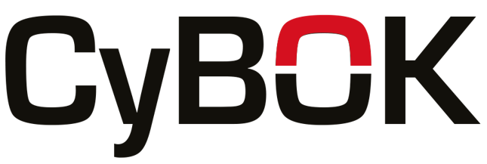

**Digital forensics in law enforcement practical exercise –**

**instructor information**

The lab invites the students to practise dead box forensic examinations using Autopsy Forensics. The “instructions for students” document contain the lab instructions and is ready to be provided to students. The students also need the forensic disk image phishy.E01. The disk image and more elaborate information for teachers is available upon request. The reason is that openly sharing the disk image and information about would compromise its integrity as a student assignment. The questions and tasks in the lab can be freely modified at will. However, any use of the lab and associated files in original or modified format should include reference to CyBOK and the creator of the files, Joakim Kävrestad and Jönköping School of Engineering.

For requests and questions relating to the material, contact Joakim Kävrestad at Joakim.kavrestad@ju.se

In addition to the CyBOK knowledge area on digital forensics and the course material developed in the project, the following book can be a valuable source of information for students doing this assignment.

Kävrestad, J., Birath, M., & Clarke, N. (2024). *Fundamentals of Digital Forensics: A Guide to Theory, Research and Applications*. Springer International Publishing. <https://doi.org/10.1007/978-3-031-53649-6>

© Crown Copyright, The National Cyber Security Centre 2024. This information is licensed under the Open Government Licence v3.0. To view this licence, visit <https://www.nationalarchives.gov.uk/doc/open-government-licence/version/3/>.

When you use this information under the Open Government Licence, you should include the following attribution: CyBOK memory analysis workshop slides © Crown Copyright, The National Cyber Security Centre 2024, licensed under the Open Government Licence: <https://www.nationalarchives.gov.uk/doc/open-government-licence/version/3/>.